  
Student Name CHRISTOPER CYRON

Student ID TP025574

Module Code CT071-3-5-3-DDAC

Intake Code UC3F1706SE

Submission Date 13TH APRIL 2018

Lecturer Name DR. KALAI ANAND A/L RATNAM

Assignment Title Container Management System (CMS)

**Acknowledgement**

I take this opportunity to express my appreciation to DR. KALAI ANAND for his excellent direction throughout the course, also for the encouragement and guidance to develop this project. The skills, assistance and direction given by him convey me to continue a long way to come up with developing application in the Cloud.

I also take this chance to express an insightful feeling of appreciation to my dear friends for the support, important information and direction, which enabled me on finishing this assignment through different stages.

Lastly, I am grateful to my parents, brother, sisters and other friends for the constant support and cooperation as well as endless encouragement which pushed me up to complete with assignment within time required and with desired outputs.

Table of Contents

**1.0 Project Background** 4

**1.1 Objectives** 4

**1.2 Scope** 5

**1.3 Requirement Specification** 5

**2.0 Project Plan** 5

**3.0 Design** 7

**3.1 Cloud Design Patterns** 7

**3.1.1 Cache Aside Pattern** 8

**3.1.2 Event Sourcing Pattern** 9

**3.2 Architectural Diagrams** 10

**3.3 Design considerations** 10

**3.4 Modelling** 11

**4.0 Implementation** 14

**4.1 Publishing to the Azure** 14

**4.1.1 Web Admin using Active Directory** 16

**4.1.2 Database Hosting on SQL Azure** 19

**4.1.4 Investigate & Analyze Application (Plan, collect, and interpret diagnostics and instrumentation data)** 20

**4.1.5 Traffic Manager** 21

**4.2 Source Code** 22

**5.0 Test Plan & Testing Discussion** 25

**5.1.1 Administrator Test Plan** 34

**5.1.2 Partner Test Plan** 35

**5.1.3 Customer Test Plan** 36

**5.2 Unit Testing** 37

**5.3 Performance Testing** 39

**5.4 Metrics** 41

**6.0 Evaluation and Conclusions** 42

**6.1 Evaluation** 42

**6.2 Conclusion** 43

**7.0 References** 44

**8.0 Appendices** 45

# **1.0 Project Background**

Maersk Line is one of the global container division and the biggest operating part of the A.P. Moller – Maersk Group, a Danish business multinational. It is the world's biggest container shipping company having clients through 374 offices in 116 countries. It employs almost 7,000 sea farers and nearly 25,000 land-based people. Maersk Line functions over 600 vessels and has a size of 2.6 million TEU. The company was initiated in 1928. Functioning in 100 countries and transferring goods around the world, at first look it would appear Danish shipping company Maersk Line is already managing all the cargo it can accomplish. But when Maersk identified that the volume of most of the goods it was shipping had grown to maximum capacity, the corporation decided that cloud powered solutions would be a decisive part of rectifying the situation. “There was a ‘eye-opener’ where Maersk said, ‘How can we back the overall business policy, and from an IT perception,” says Soeren Lorenzen, an account general manager with Hewlett-Packard corporation who is involved first-hand with Maersk’s ITO hard work. “There was a new CIO who wanted to contract out every part of IT, but without [harmfully] impacting shipping.” To assist further business growth and upsurge organizational flexibility, Maersk decided to combine all its data centers and server rooms operating international onto a virtualized platform. Microsoft Azure was previously hosting some of Maersk’s IT environment, and in March 2016 Maersk firstly approached Microsoft about increasing the scope of the relationship. Moving onward, Lorenzen says Maersk is presently changing over its IT setup based on Microsoft Azure, beginning with the desktop environment up to container management.

## **1.1 Objectives**

The objectives of this project are defined to support the following areas:

⮚ **Provisioning** The developer must be able to provision the new container application to the Microsoft Azure Platform.

⮚ **Maintainability-** The developer must be able to upgrade the container application and accomplish other maintenance tasks while numerous tenants are using it.

⮚ **Monitoring –** The developer must be able to monitor the application always to recognize any problems and to troubleshoot them. This comprises monitoring how each tenant is using the system.

⮚ **Availability:** Tenants want the system to be continuously available, perhaps with assurances defined in an SLA. Again, the events of other tenants should not affect the availability of the system.

⮚ **Scalability:** The system scales to meet the demand of the system.

## **1.2 Scope**

Maersk Line, is looking at designing and developing a Container Management System (CMS) to cater to manage the containers, a solution that reduces overall supply chain costs and an efficient way to manage logistics.

## **1.3 Requirement Specification**

You are required to design and develop a single tenant web solution that meets the following criteria as below:

1. From import, export and transshipment processing to gate operations.

2. To be able to scale the solution to meet the needs of demands during peak seasons.

3. Improves profitability, cuts costs, increases productivity, eradicates errors and optimizes resources to future-proof your cargo handling business for high performance.

4. Assurance & reliability through Failover Management.

5. Accurately allocates inbound containers to yard locations and plan outbound containers to individual heavier vehicles, delivering an exceptional level of automation and removing human error.

6. Manage your entire booking process from schedule search to booking confirmation

# **2.0 Project Plan**

The project plan includes all the tasks and activates that need to be undertaken to develop the  
project together with due date. Project plan is the practice of knowledge, services, tools, skills and appropriate methods to achieve desired outcomes (PMBOK, 2009). A project schedule for the duration of four months must develop to manage the order of activities that developer has to accomplish for a successful project. The development of web application for container management must meet the schedule and requirements of the company. In the planning stage, the developer was required to have the followings tools available:

⮚ Creating an account on Microsoft Azure  
⮚ Asp.Net and Visual Studio 2014 Express Edition  
⮚ SQL Server 2012 for Managing the Data.

Based on the case study given for the container management, the following assumptions has been made:

✓ The container management web application needs to provide users with functions such as selecting desired containers and making reservation together with confirmations. The users can access to the website through registration, which include the basic information. All the data of customers will be stored in the database cloud including all the reservation and transactions made. This will provide security of data and for the users of system.  
✓ The container management web application has to provide users ability to compare itineraries prior to confirm ordering the containers. Users need to be able to see the offers and discounts during a special occasions. They need to be able viewing in detail the information for any pointed destination. Each reservation should include the date, location, ship, and containers.  
✓ The System Administrator of the container management website should be able managing all the staff of company with data stored in the Azure. Also, get access to the information of the containers, and all the reservations. Besides, administrator should be able to delete and update information in case changes are required.

**Gantt Chart**

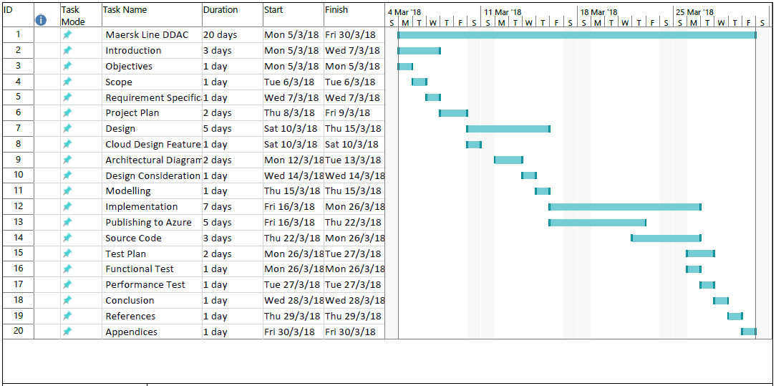

# **3.0 Design**

The design of the Maersk container management web application requires implementation of various ASP.Net web forms to be able including all the required functionalities. The application structure as it is described in Visual Studio 2012 Solution contains Admin and User.

|  |  |
| --- | --- |
| For a customer to make booking, they have to go through steps which lead them from one page to another. The process is as follows:   * The Defult.aspx to select containers with details. * Login.aspx Page shows the entry gate to be accessed by all the users. * DataConnection.cs contains the database string. * AboutUs.aspx contains the details about system. * Customer Folder contains all the files related to Customer functions. * Partner folder contains all the files related to the partner features.   Besides, there are other folders like image to save the images,scripts for saving the scripts like javascript files. |  |
|  |  |
|  |  |
|  |  |

## **3.1 Cloud Design Patterns**

Patterns computer graphics design Cloud Microsoft is a good reference design patterns cloud architecture. The info graphic shows the most common problems in designing applications on Microsoft Azure cloud:

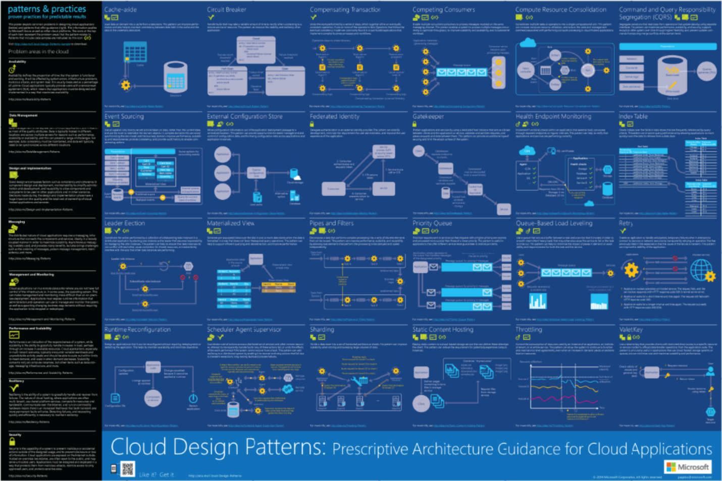

### **3.1.1 Cache Aside Pattern**

This pattern is useful to optimize repeated access to information which are in a data store. Web application need to implement this strategy to ensure that data in caches is up to date as much as possible, but should be able also to detect and handle circumstances that rise when the data that are in caches have become stale. This pattern is useful for container management application since many data are involved and being able to optimize them can save space and increase performance. The advantage of using this pattern is that any data stored in the catches are directly written in the data store.

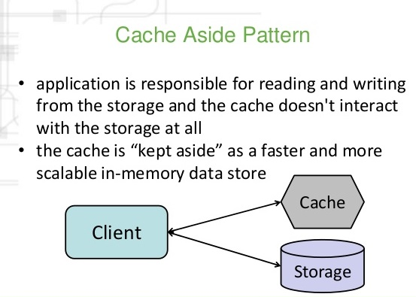

### **3.1.2 Event Sourcing Pattern**

The applications that work with large data need to have this type of pattern to maintain the current state of data and users by updating and deleting them at any time even when users are working with the system. Event sourcing it is a pattern for handling operations on the data that is determined by the event sequences, where each of them is recorded in the append-only store.



The Event Sourcing pattern provides many advantages, including:

* Enabling the user interface workflow who initiated the action that produced the event to continue tasks which on execution of transaction can massively improve performance and scalability especially for the user interface.
* Events describe action that occurred, with the associated data needed to describe the action characterized by the event. Events do not directly update a data store, but they only record for handling at the appropriate time.
* Another advantage is that event sourcing are able to prevent concurrent updates from initiating conflicts because it avoids the requirement to directly update objects in the data store.(Homer, 2012)

## **3.2 Architectural Diagrams**

The container management system consists of Azure website which is managed by the administrator. container management booking offers users ability to see all the possible container management details which then are saved to database in they user continue filling the details. View container offers users the view of the people who have already booked containers.

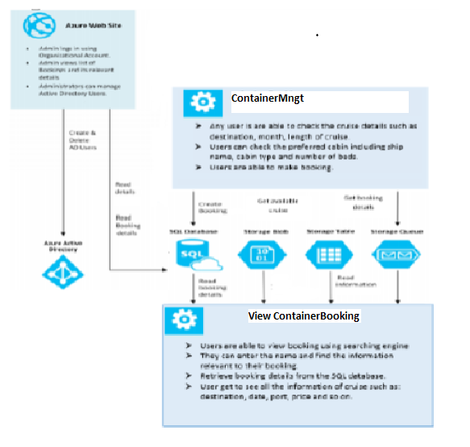

Figure 1. Architecture Diagram

## **3.3 Design considerations**

To use cloud computing with the Azure platform for more than simple hosting, it is required to explore a vast array of options available for designing solutions. First of all, Azure platform offers four distinct storage models: Blob, Table, Queue, and SQL Database. Storing data in SQL Database is like storing data in SQL Server. All what is required is issue T-SQL statements and review the limitations of the syntax specific to SQL Database. The ability to store data in SQL Database using T-SQL offers unique opportunities. In many cases, can easily extend or port certain types of applications in SQL Database with no modifications. This portability allows to either implement solutions that directly depend on SQL Database for storage, or to use a local database while using SQL Database transparently for additional storage requirements.

**Loading suitable volume of Data for Testing**

In order to get good performance of database on Microsoft Azure platform, the data should be tested and be prepared according to the subset of the actual world volume. Sometimes has less booking and sometimes the number of users become higher which may cause direct problem with the database, hence it is difficult to know whether database is capable to manage all the users. The queries play an important role to ensure smooth process of booking for the passengers.

During the implementation the Entity Framework has database initializer which permits the developer to put data every time it is initialized in the database. Hence, as solution database initializer has to be created and the job of developer is to create a good and organized data from the system. Those data can be created on different tools and then taken into the database.

**Scale-out not Scale-up**

Moving from one on promises application to azure could services it is in relation on how the scale is done. In cloud the gate to reach scalable applications is to use the explicit design for scale-out. The developer has to identify the aspect of application which depends on scale up services and make sure to convert to scale out. The main contender for a scale up dependency is the relational database SQL Server or in this case Azure SQL Database. Although it is difficult to implement but it is worth it.

## **3.4 Modelling**

Every Software Systems has to be carefully analyzed, designed and modeled before moving to development and deployment. This project delivers large scale modelling of a container management software system. The emphasis for the container modeling will be database construction, tables with entities and attributes as well as techniques appropriate for Asp.Net with SQL server and Azure development. By analyzing the Maersk activities, the following tables have been created on SQL server:

Customer (CustomerID, Password, Email, Address, PhoneNo, Name, RoleId)

Fleet (FltID, Sheet, TotalinService, Seats, Engines, ShipSpeed)

Partner(PartnerID, Password, Email, Address, PhoneNo, Name, RoleId)

Schedule (SchID, PackageType, Noofdays)

Shipment (ShipmentID, PackageType, Price, Weight, Description, Custmid)

Vessels (VesID, ShipType, Built, Size, GT)

All the tables are designed and connected with primary keys among each other. Each passenger is able to book one or more containers. Every reservation requires the customer details, container, cabin and ship. Each reservation has one up to four orders. Each container booking requires one container, but each container can have many containers during the year. The entity relationship diagram for the container management describes the relation among all entities directional or unidirectional.

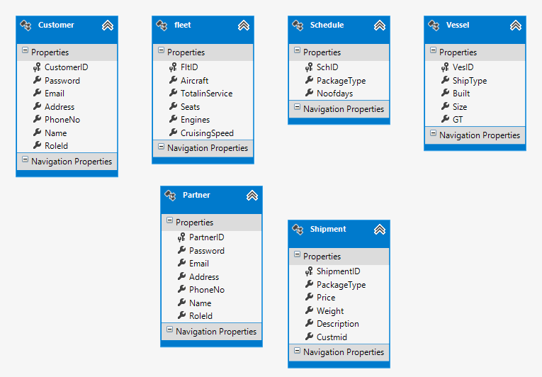

**Use Case Diagram**

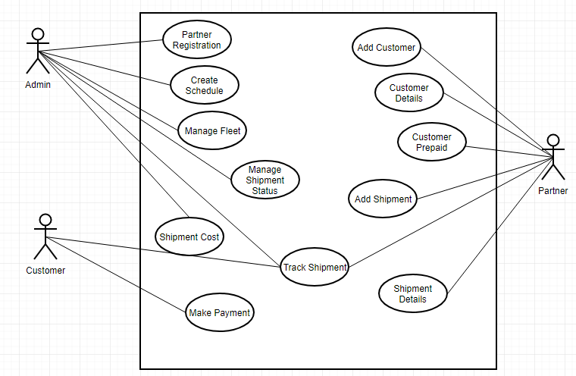

**Sequence Diagram**

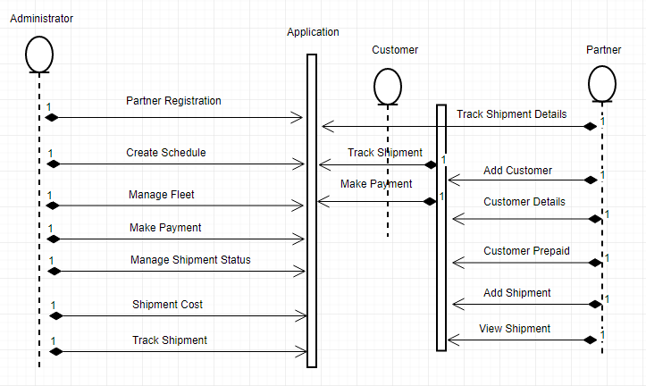

# **4.0 Implementation**

## **4.1 Publishing to the Azure**

The web application has been created using ASP.Net with Visual Studio 2012 Express which then has been deployed to Microsoft Azure. Initially, is creating Microsoft Azure AD directory with single tenant as part of Microsoft Account based in Azure subscription. Then, it is created new directory users registering to enable Web sign onto application. More explicitly are described below all activates that have been undertaken to publish web application into Microsoft Azure Portal:

* Access to Azure Portal using Microsoft Account
* Make an active subscription to be able accessing components required for the project.
* A cloud service which runs administrator roles within the Azure environment.
* A storage account which enables access to the Azure blob, queue and table services.
* Authentication credentials which are used to authenticate requests to Azure.

On the other hand, the tasks that have been accomplished are as follows:

Migration of web application for deployment to Azure.

Setting up services to support the Azure cloud service.

Publishing Azure cloud service that have been developed in Visual Studio Enabling the view and monitoring of published Azure cloud services.

After each implementation on visual studio, it is published on Azure portal by clicking to the project with the right lick and choose option publish as shown in figure below:

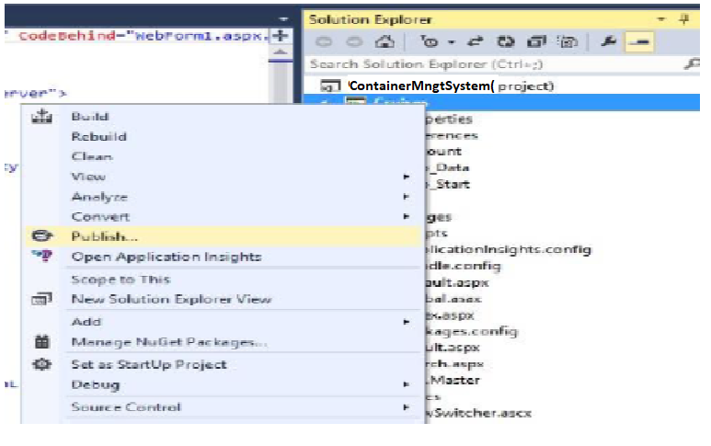

Azure it was to create the hosting service for Cloud Services, and then the project was modified to deploy its source codes to the hosting.

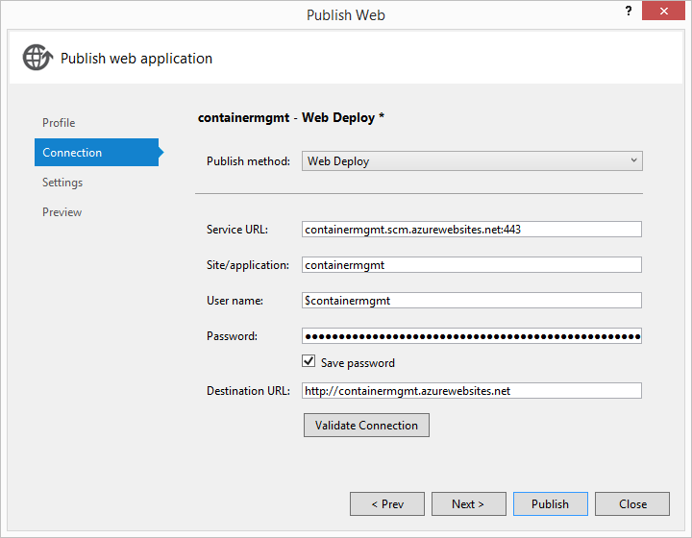

The figure below shows all the items that have been published to the Microsoft Azure including: ¬

* Storage Account,
* Cloud Service
* SQL Database

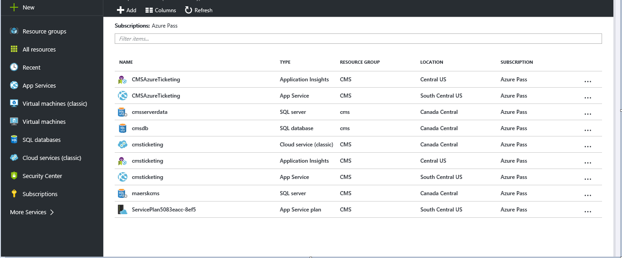

### **4.1.1 Web Admin using Active Directory**

Being able to manage user credentials and application access it is considered sophisticated on this so called cloud era. Besides, managing access with traditional on premise application also has its difficulties with managing third party cloud based applications. Security of discrete identity using passwords is considered outdated. However, Windows Azure gives its users an advantage by offering easily the ability to gain visibility and centralized control over identity management using: Windows Azure Active Directory or Windows Azure Multi-Factor Authentication.

Container Management project is developed with the following Azure components:

* Azure Active Directory for web Admin
* Azure Web Site for passengers booking container

As requirement for creating Azure Active Directory is to have Azure Management Portal so that it can be integrated the project. Below will be shown in steps all the activities for creating Active directory together will snapshot of each step:  
  
First, is required Settings for Authentication to be changed to Organizational Accounts:



The second step requires the project to setup with “Host in the cloud”, with the help of wizard to create an Azure Web Site account within Microsoft Visual Studio. In this section is required to set the current region Canada and enter other details such as one single organization, email address, access level, and single sign on, ready directory data.







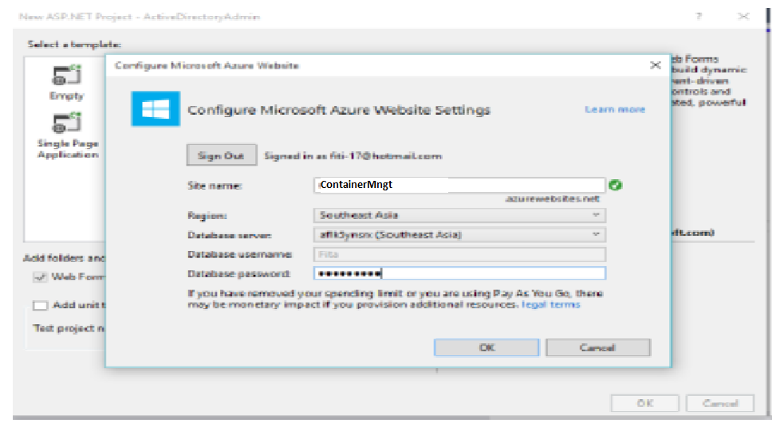

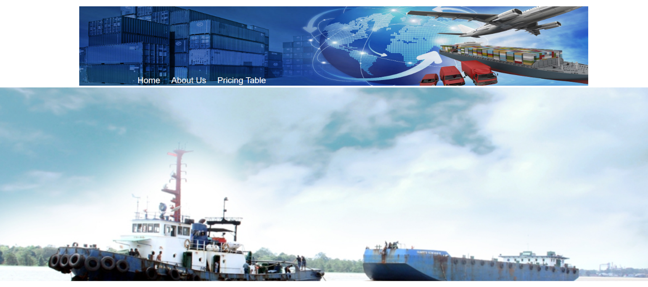

### **4.1.2 Database Hosting on SQL Azure**

The database in the Azure supports storing and managing a large number of data. SQL database is created whenever a new server is created within a same area as Web Admin Azure. This case is used south East Asia for all the direction. According to Microsoft this would support on saving the egress bandwidth cost and data latency. When the SQL databases in created the connection strings are achieved and the application is ready to use them.

Create a SQL database instance and logical server:

* Click NEW at the bottom of the page.
* Click Data Services.
* Click SQL Database.
* Click Custom Create.
* Enter a Name of database

In this case SQL is created with name contdb

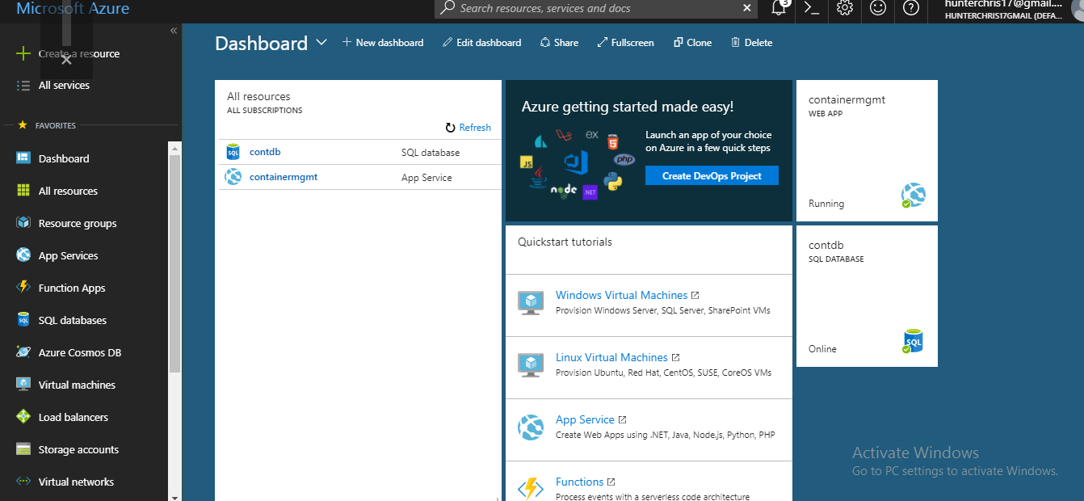

In this section can be chosen edition, maximum size, and collation.

There is also another way to host the SQL database from SQL server and migrate it to the cloud. The data then will be stored in the Azure and works. Tables that have been created are:

Customer (CustomerID, Password, Email, Address, PhoneNo, Name, RoleId,Balance)

Fleet (FltID, Container, TotalinService, Seats, Engines, ShipSpeed)

Partner(PartnerID, Password, Email, Address, PhoneNo, Name, RoleId)

Schedule (SchID, PackageType, Noofdays)

Shipment (ShipmentID, PackageType, Price, Weight, Description, Custmid,Status)

Vessels (VesID, ShipType, Built, Size, GT)

The tables created in more details are described earlier under the Design in section

### **4.1.4 Investigate & Analyze Application (Plan, collect, and interpret diagnostics and instrumentation data)**

Windows Azure Diagnostics allows users to collect diagnostic data from application available in Azure. There are several data available such as troubleshooting and debugging, performance measurement, monitoring resources and traffic analysis and capacity planning. Once the diagnostic data is collected it is able to be transferred into Azure storage with either scheduled or on-demand.

Below is shown how to identify, diagnose, and troubleshoot Azure Storage related issues.



Monitoring allows developer to view metrics including availability, average latency, total requests, perforce, errors and the numbers for a storage account.

### **4.1.5 Traffic Manager**

Azure Traffic Manager aids to decrease downtime and make better the responsiveness of important applications by steering incoming traffic across numerous deployments in diverse regions. Built-in health checks and programmed re-routing benefit to ensure high availability if a service flops (Azure, 2017).

Use Traffic Manager to:

* To improve the web-app availability with automatic failover.
* Intensification Maersk Line web-application’s responsiveness by steering end users to the Azure location with lowermost network latency.
* Impeccably combine on-premises and cloud.
* Permit Business Continuity and recuperate from disaster.

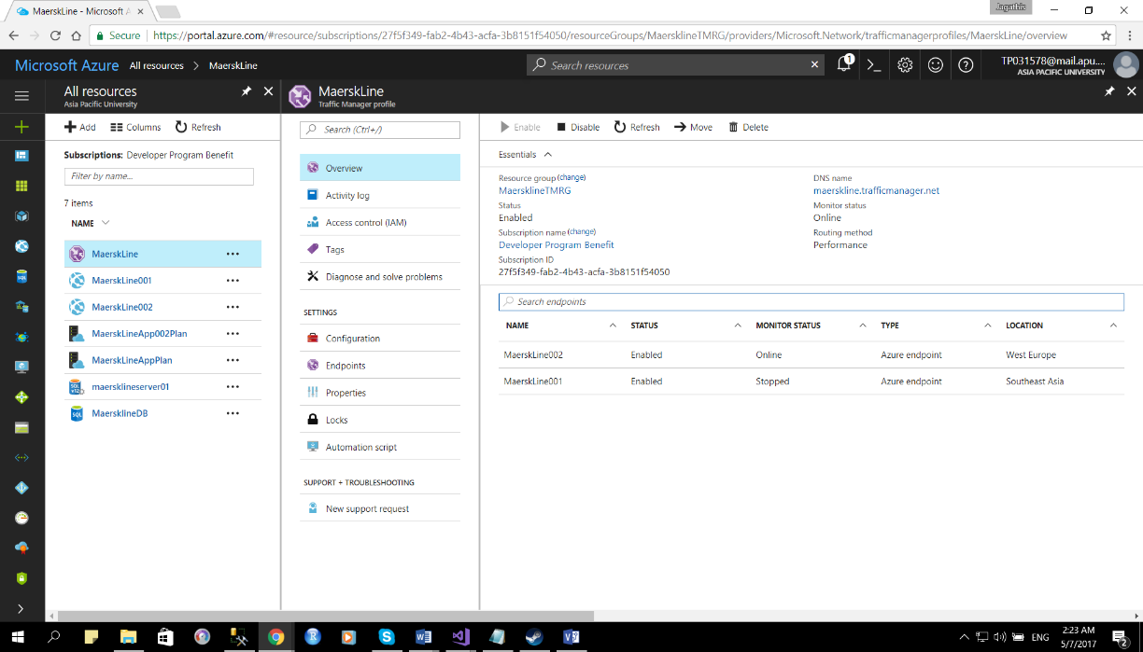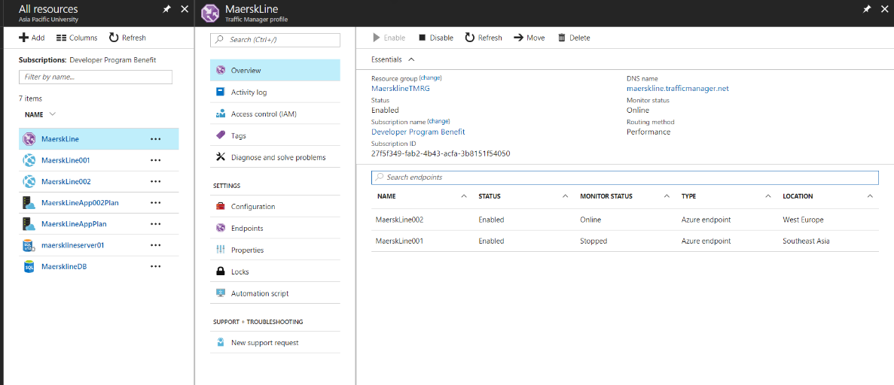

**Traffic Manager that contains the both Endpoints**

## **4.2 Source Code**

**Add Containers**

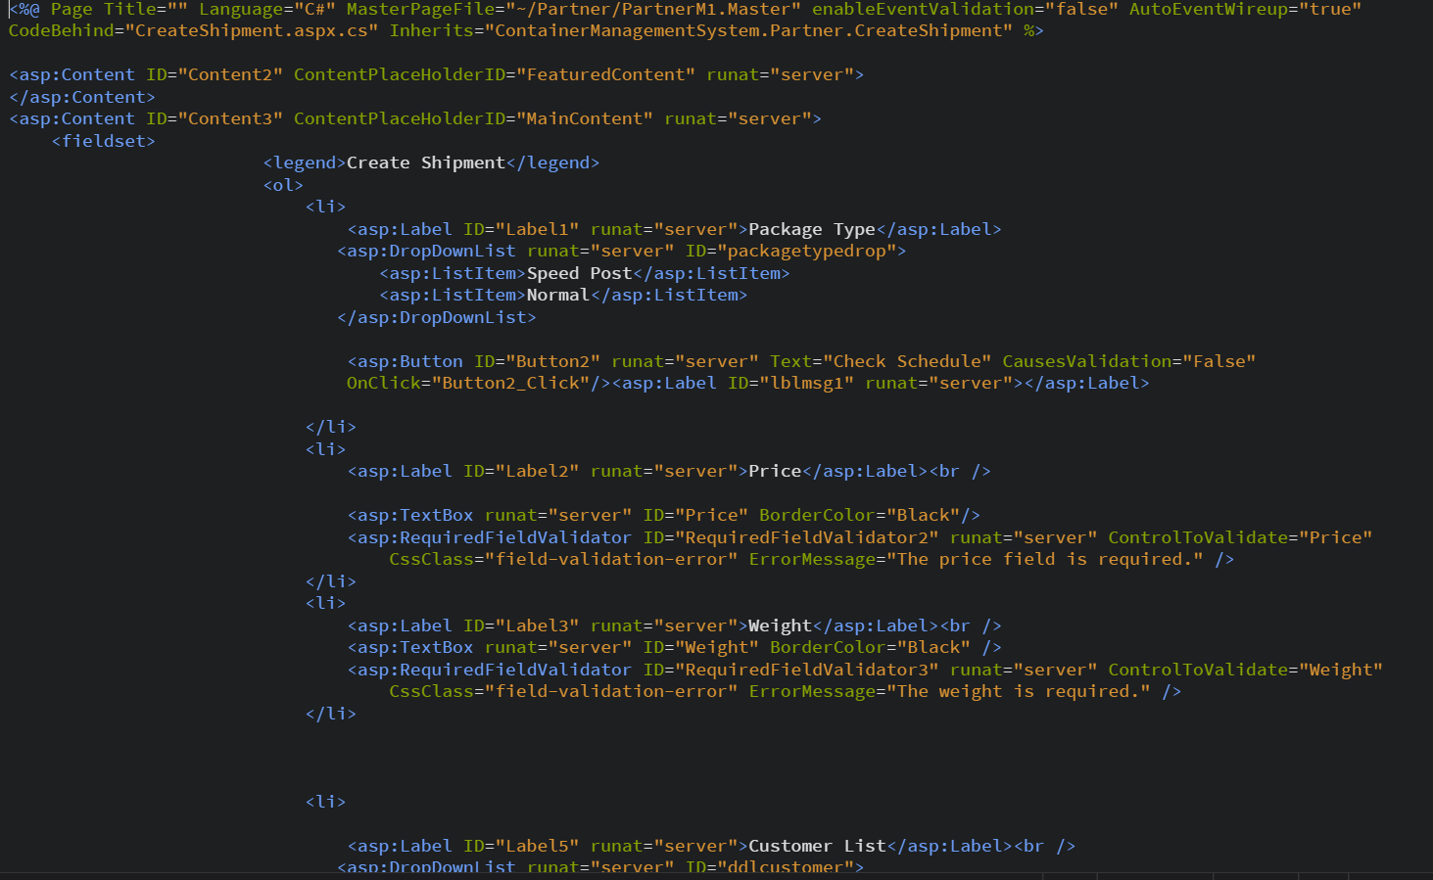

**Add Customers**

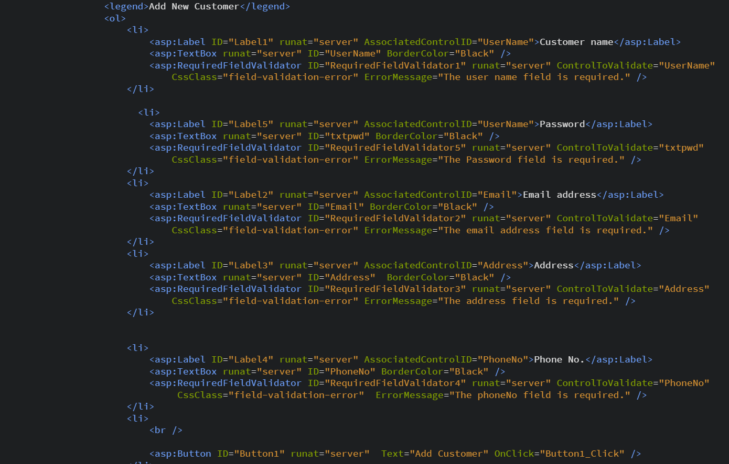

**Edit Customer Details**

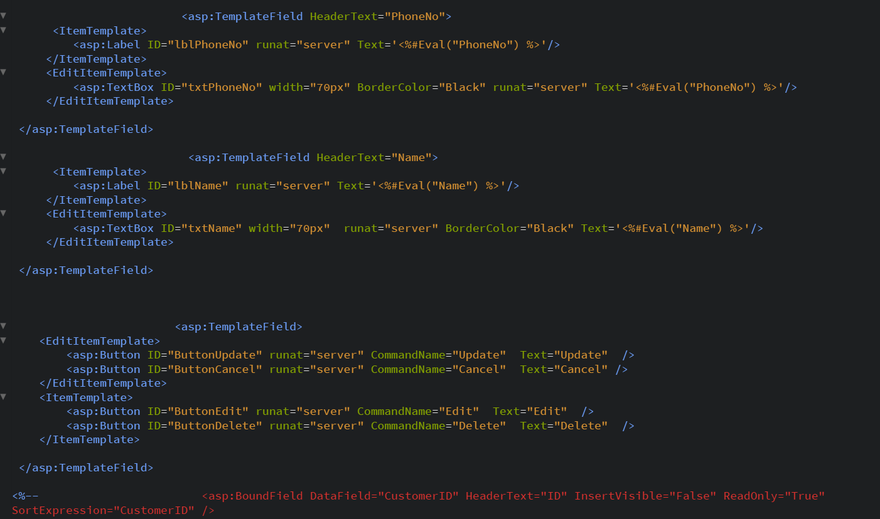

**Manage Containers**

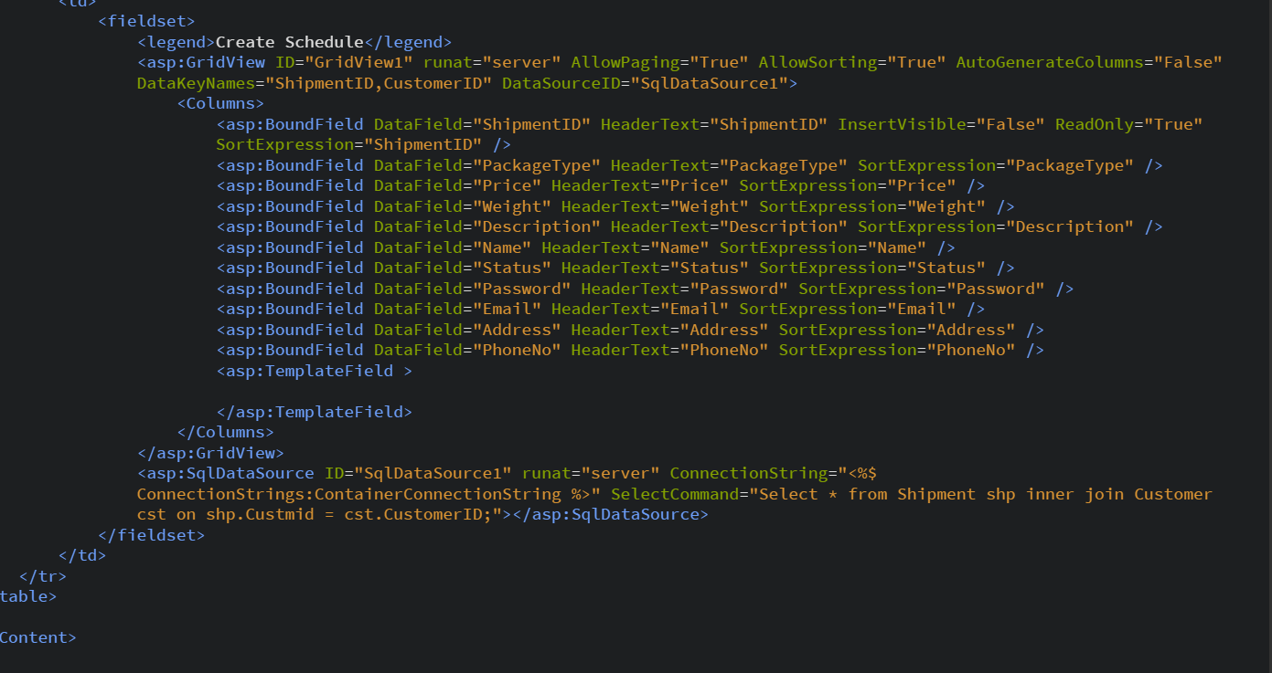

**Track Container Schedule**

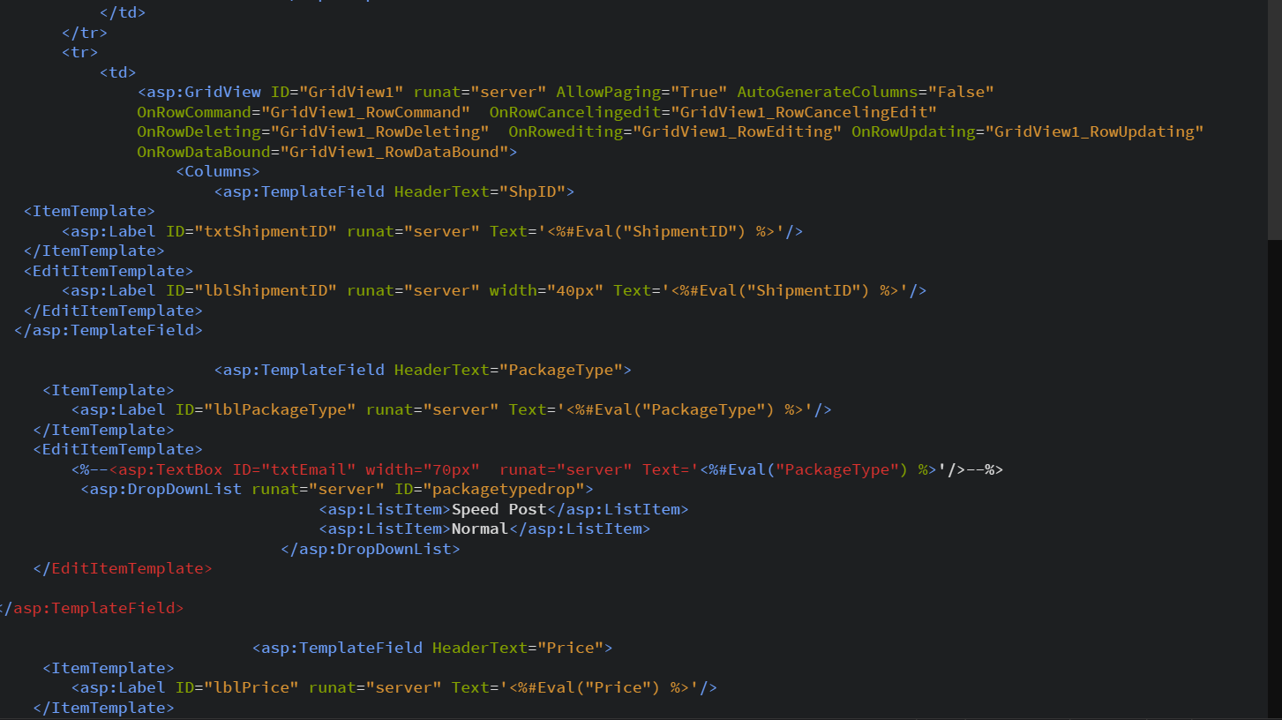

# **5.0 Test Plan & Testing Discussion**

This section includes testing plan for the application. This testing enable user to understand whether the system is running based on the requirements specified in the cloud.

The functions that will be tested for the system:

**Login Page**

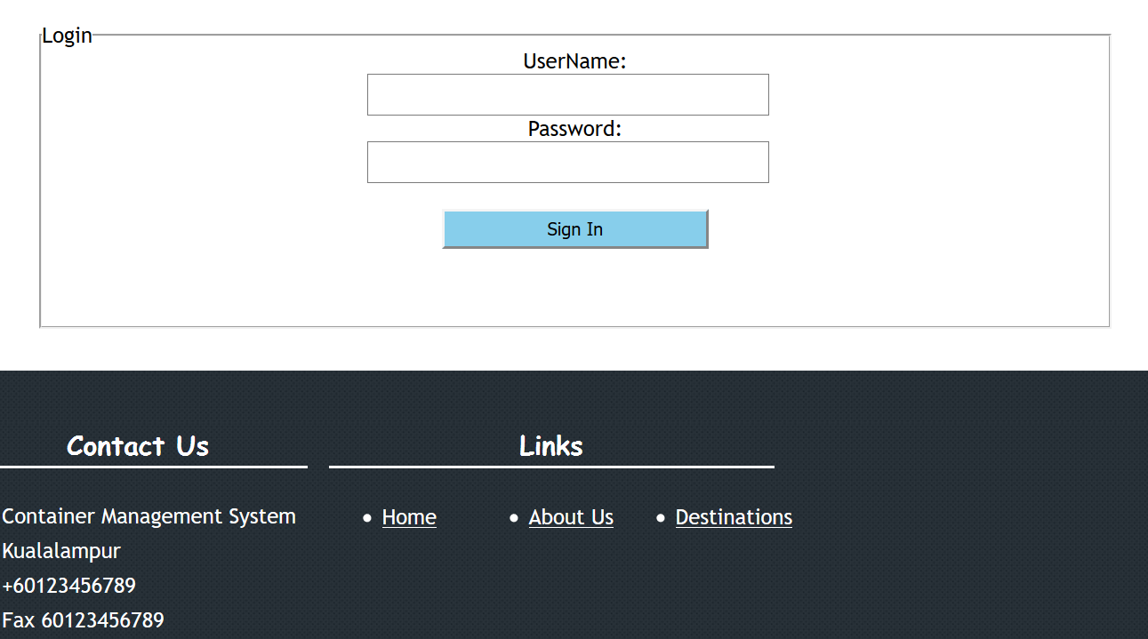

Login page would be Entry gate for the Admin login along with the user login. The login page would asked users and admin user to enter the username and password for respective account. Once sign in button get clicked it will verify user details against the database.

**Admin Panel**

**Default Page**

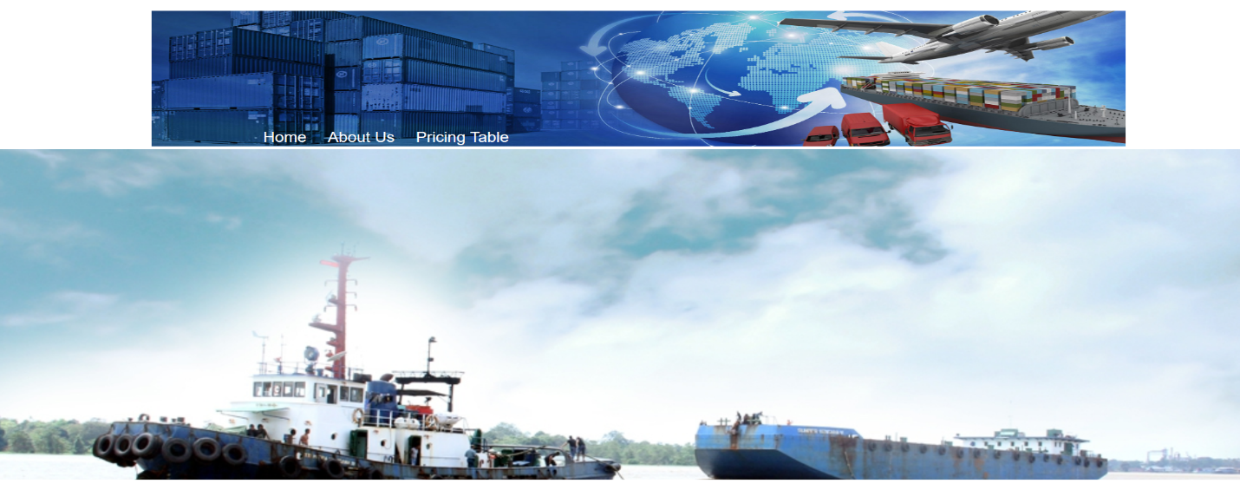

This is the design going to display on the landing page for admin after login. From here Admin will be able to perform other features as well in order to operate with whole system.

**Partner Registration**

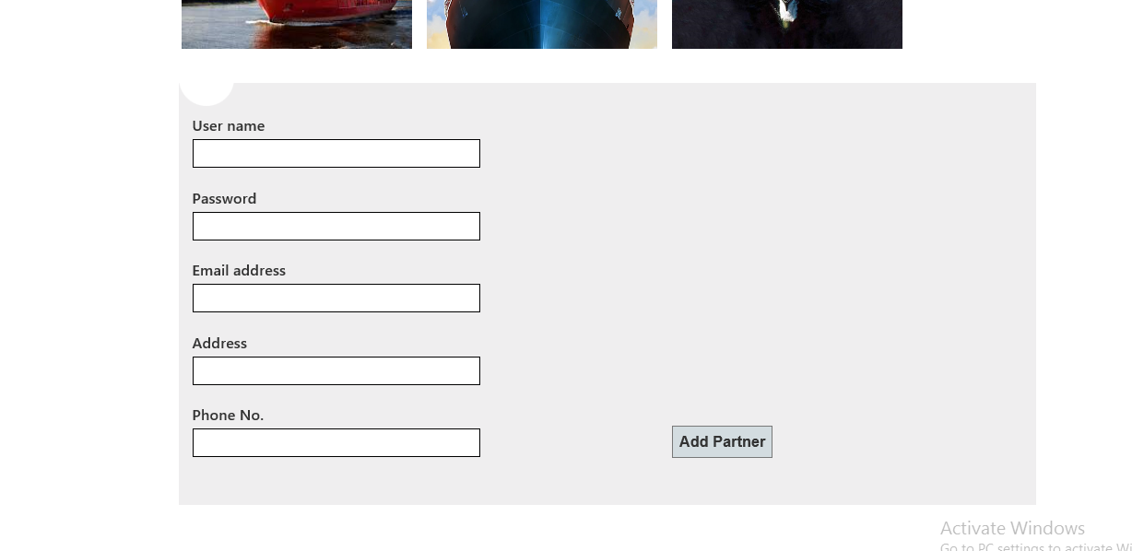

Partner Registration is going to performed by the Admin. Once added he will has his own user id password and will be able to operate with users.

**Create schedule**

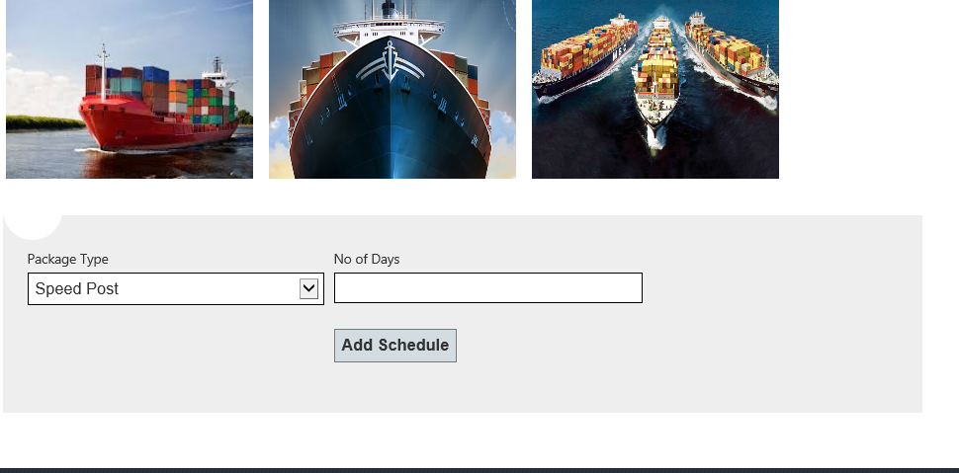

Here Admin can add the schedule for the different Post types. Currently in system there are two types of posts,

1. Normal
2. Speed Post

**Manage Fleet**

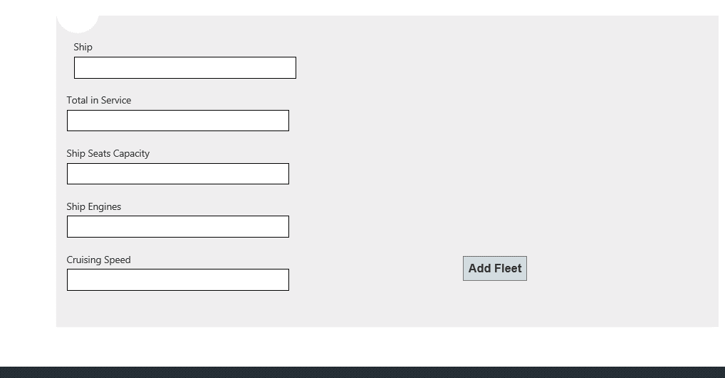

This screen is all about adding a new fleet into the system. Fleet details will be like Aircraft,Total in Service , Seats, Engines and speed as well.

**Manage Container**

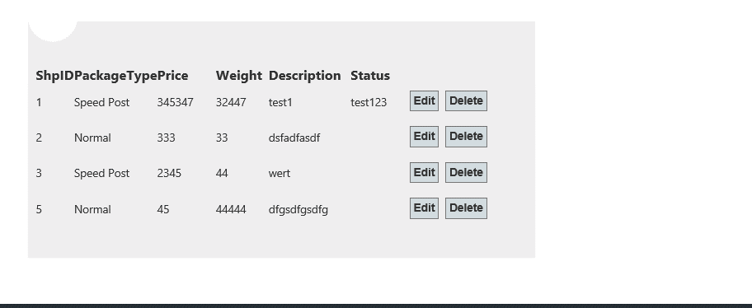

This screen is all about adding a new Vessels into the system. Fleet details will be like Container Type, Built in,Size and GT as well.

**Track Container**

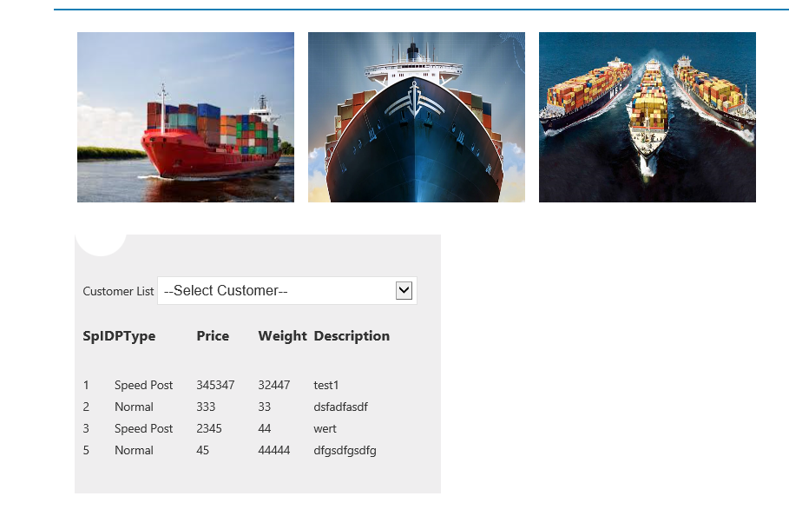

From this user interface we will be able to track the status of customer containers orders added by the partners in the system.

**Container Cost Table**

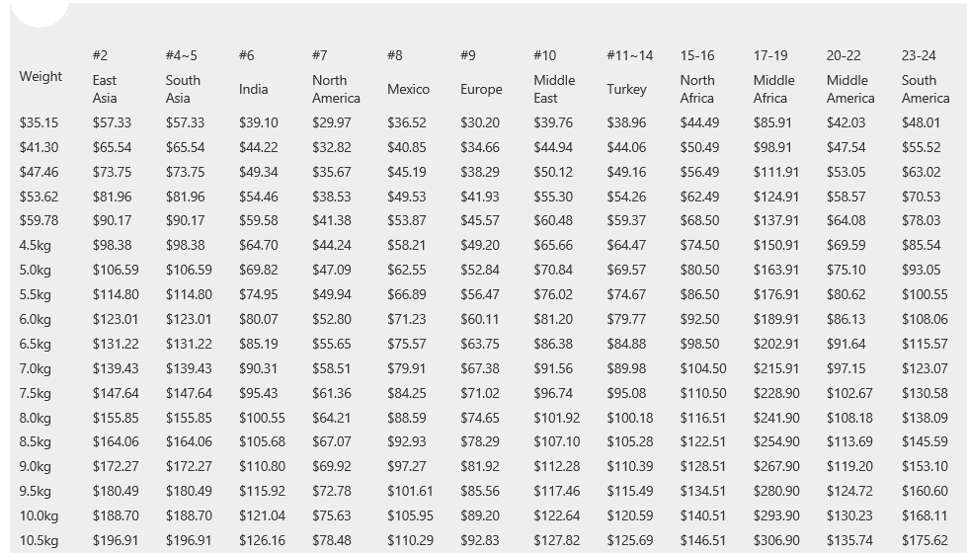

**Partner Panel**

**Default Page**

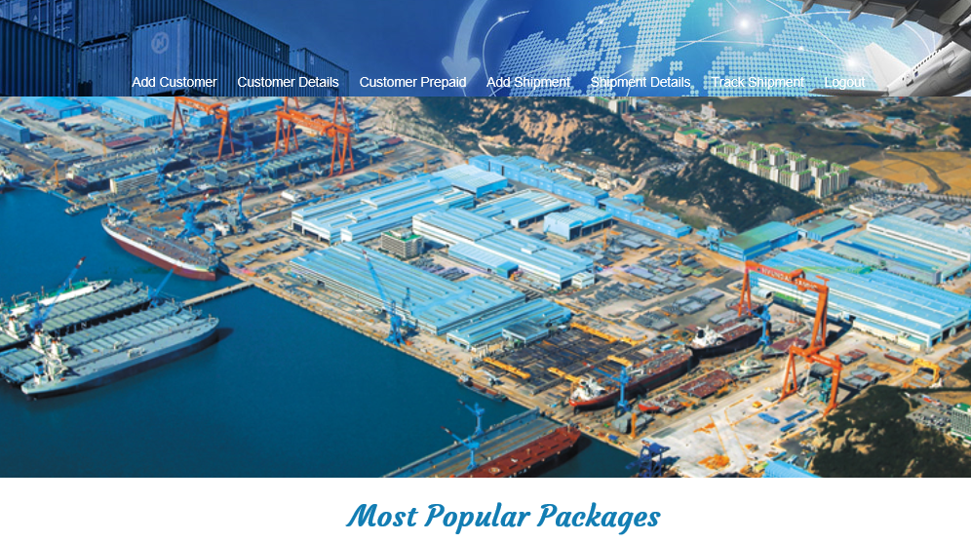

This is the design going to display on the landing page for partner after login. From here Partner will be able to perform other features as well in order to operate with whole system.

**Add Customer**

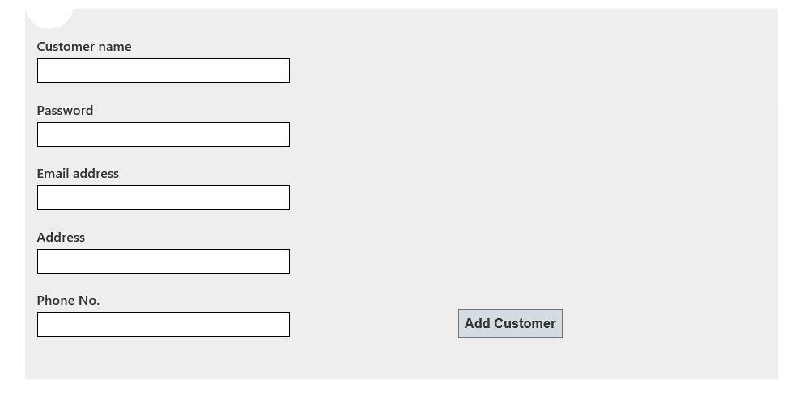

This screen will help partners to add new customers on into the system. Customers input values will be like Name, Password, Email Address, Address and Phone No.

**Customer Details**

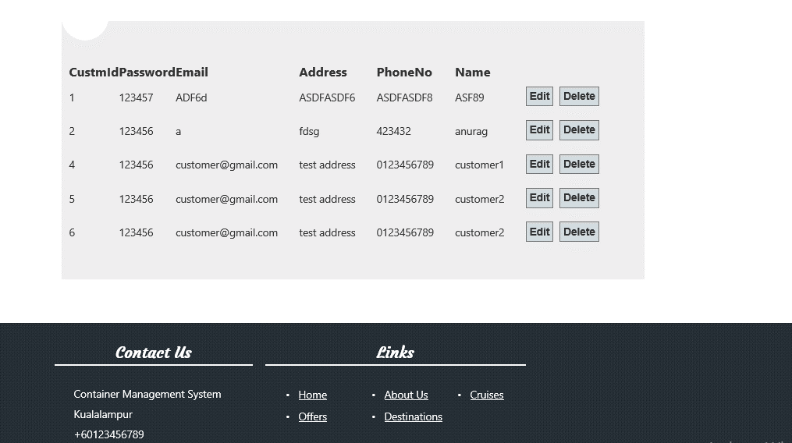

This page contains all the details of registered customers inside the system. Customer can be Edited and deleted from this page as well.

**Create Shipment**

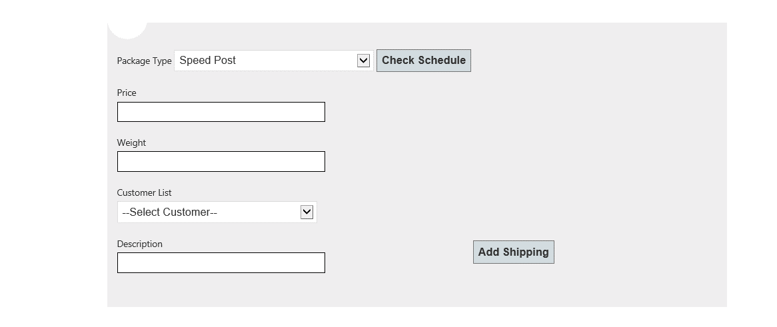

Create shipment is the page where partners will be able to check the schedule for the package types and will be able to add shipping into the system.

**Shipment Details**

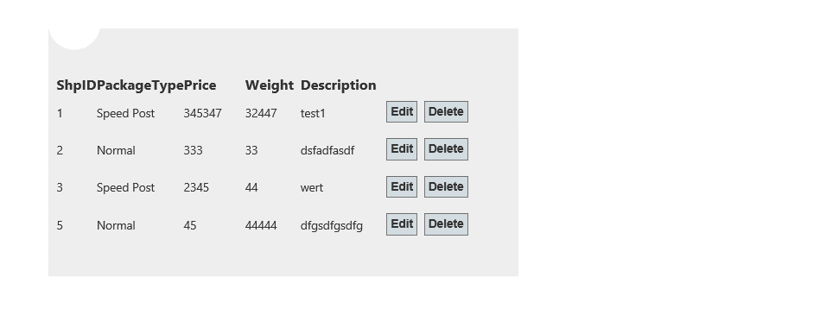

This page is about to display all the details related to the shipment. Also details can be edited/deleted from here as well.

**Track Shipment**

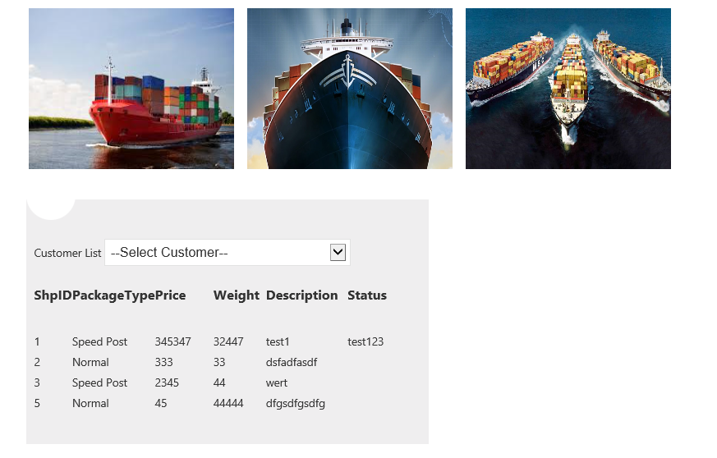

This will be the user interface from where Partners will be also able to track the status of customers shipments.

**Customer Prepaid**

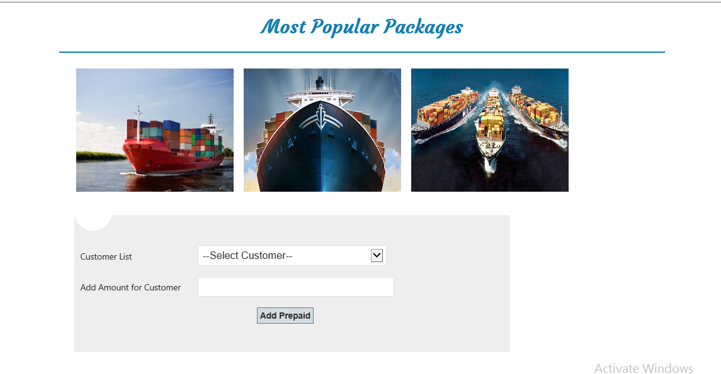

**Customer Panel**

**Default Page**

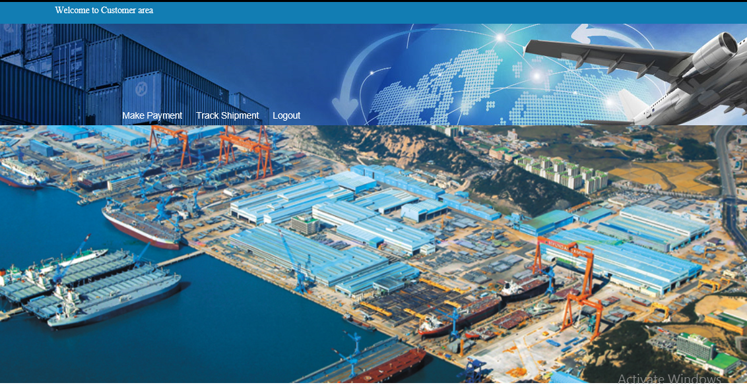

This is going to be the default page user interface for the users.

**Make Payment**

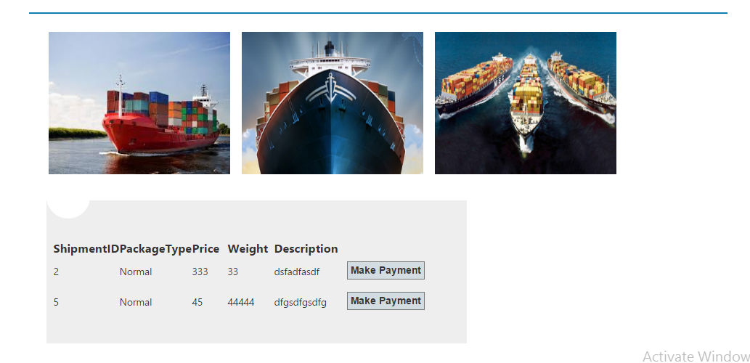

Users can do the payment from this page for the booked shipment.

**Track Shipment**

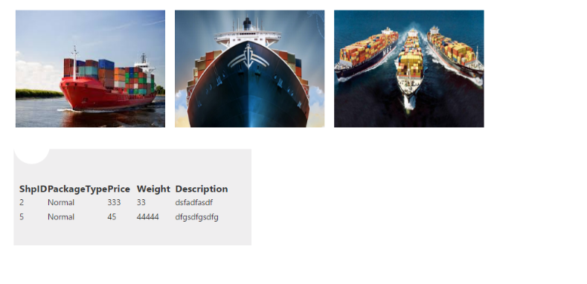

Shipment tracking for users can be done from this page.

### **5.1.1 Administrator Test Plan**

First of all it is important to know all the activities of admin and his role. Admin is able to log in and has privileges to add, delete and modify or updates users. Below is give activity diagram which shows all the activities that admin can do in the webpage.

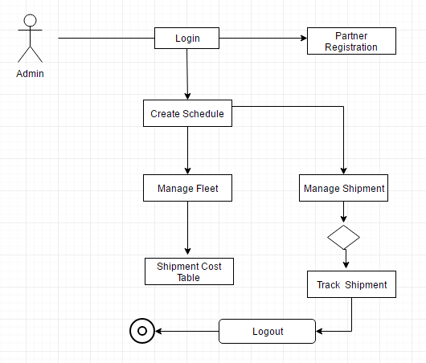

### **5.1.2 Partner Test Plan**

First of all it is important to know all the activities of partner and his role. Partner is able to log in and has privileges to add, delete and modify or updates customers and Shipping details. Below is give activity diagram which shows all the activities that partner can do in the webpage.

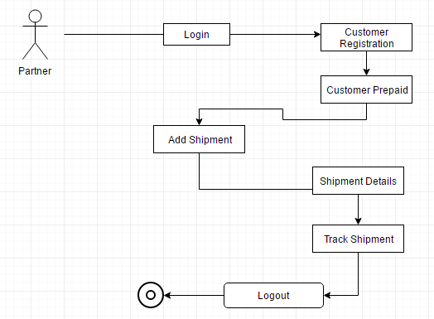

### **5.1.3 Customer Test Plan**

First of all it is important to know all the activities of customer. customer is able to log in and has privileges to Make Payment and Track Shipment. Below is give activity diagram which shows all the activities that customer can do in the webpage.

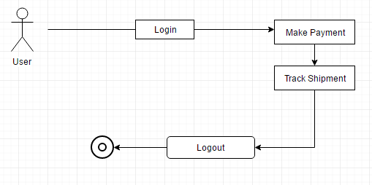

## **5.2 Unit Testing**

Unit testing focusses on the verification effort for the smallest unit of a software design and it’s components. As an important guideline, the component level design descriptions are used, so that the control paths are tested to discover any faults within of the software component. Each unit of the web application will be tested. The developer will perform the testing on the units in the Container Management System (CMS).

Name of the System: **Container Management System (CMS)**

Description: **Unit Testing**

Tester Name: **Christoper Cyron**

Date: **27th February 2018**

**Container Management System (CMS) main page (web application)**

|  |  |  |  |  |
| --- | --- | --- | --- | --- |
| **Test cases** | **Type of input** | **Expected Result** | **Actual Result** | **Remark**  **(Pass/Fail)** |
| Menu list display | none | Menu list is to be displayed | Menu list displayed | Pass |
|  | input | Redirect to page | Redirected to page | Pass |
|  | input | Redirect to page | Redirected to page | Pass |
| Feedback option | input | Redirect to login page | Redirected to login page | Pass |
| option | input | Redirect to page | Redirected to page | Pass |
| Notifications option | input | Redirect to notifications page | Redirected to notifications page | Pass |
| rating option | input | Redirect to rating page | Redirect to rating page | Pass |
| Contact us option | input | Redirect to contact us page | Redirected to contact us page | Pass |
|  |  |  |  |  |

**Login page**

|  |  |  |  |  |
| --- | --- | --- | --- | --- |
| **Test cases** | **Type of input** | **Expected Result** | **Actual Result** | **Remark**  **(Pass/Fail)** |
| Credential validation | Exact username and incorrect password | Redirected to empty login page | Redirected to empty login page | Pass |
| Incorrect username and wrong password | Redirect to empty login page | Redirected to empty login page | Pass |
| Exact username and right password | Redirect to homepage with available jobs page displayed | Redirected to homepage with available jobs displayed | Pass |
| Incorrect username and incorrect password | Redirect to empty login page | Redirected to empty login page | Pass |

**Announcements page**

|  |  |  |  |  |
| --- | --- | --- | --- | --- |
| **Test cases** | **Type of input** | **Expected Result** | **Actual Result** | **Remark**  **(Pass/Fail)** |
| Sending announcements | Send empty message as push | Return failed status code | Returned failed status code | Pass |
| Send with string | Return success status code | Returned success status code | Pass |

**Available Containers**

|  |  |  |  |  |
| --- | --- | --- | --- | --- |
| **Test cases** | **Type of input** | **Expected Result** | **Actual Result** | **Remark**  **(Pass/Fail)** |
| Retrieve container list | nil | Return list of containers | Returned list of containers | Pass |

## **5.3 Performance Testing**

With the performance test, container management web application can better evaluate whether the web application is prepared for the release. Feel more self-assured that Maersk Line web-app can handle the traffic during highest use or at the next marketing push (Microsoft, 2018)

These tests pretend user load on Maersk Line web-app over an exact time and measure Maersk Line web-app's reply. For instance, performance test results display how quick Maersk Line web-app answers to a precise number of users. Performance test too display how many requests were unsuccessful, which might indicate the difficulties with Maersk Line web-app.

*Set up and run Maersk Line performance test*

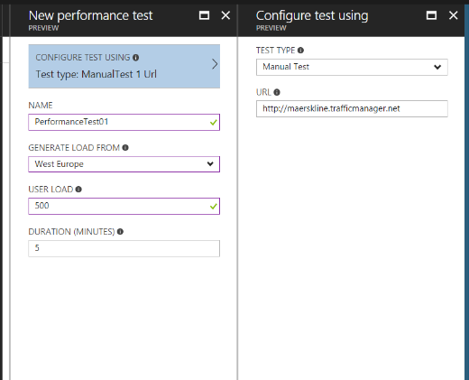

**Setting up Performance Test**

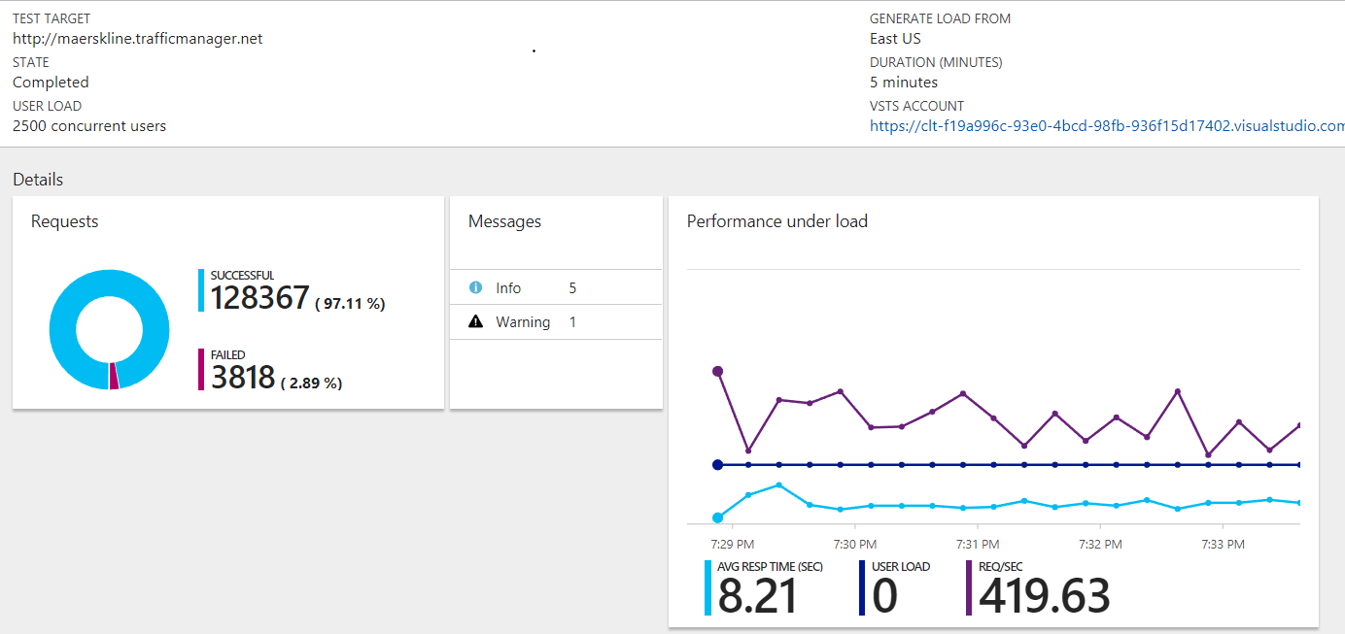

**Result of a Performance test**

In the performance test directly above where there are 2500 simultaneous users; there are 3818 cases of fault. It validates the necessity for the developer to permit scale out feature to surge the number of instances in the container management web application if the CPU usage surpasses 70%. It is to allow that all the users can access the web page even though there are huge number of simultaneous users. Otherwise, the developer can also select to scale up the application to Medium Standard (S2) or advanced as the package deliver stronger CPU power and advanced capacity of memory.

## **5.4 Metrics**

*Web App Metrics on Southeast Asia*

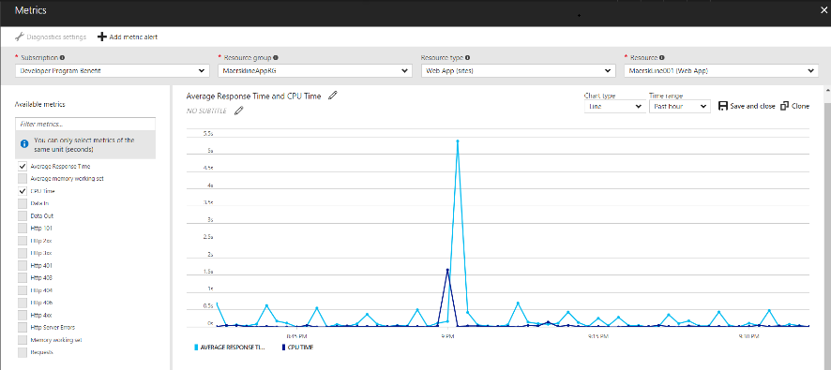

**Average response time and the CPU time for Web App 001**

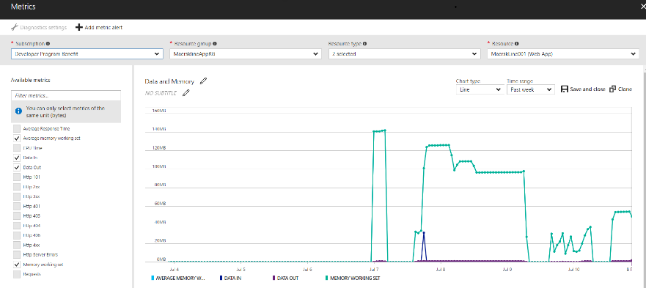

**Average memory working set, Data IN and Data OUT and memory working set for the Web App 001**

# **6.0 Evaluation and Conclusions**

## **6.1 Evaluation**

In general, the development of could application with Microsoft Azure have been challenging and exciting at the same time. The overall objectives of this project have been accomplished and the outcomes are positive. As a developer of the project, the focus was on learning in details could computing facilities and being able to connect all the tasks that Microsoft Azure offers. Basically, the tenacity of this project was to accomplish six objectives discussed on the first section of project and the outcomes are as follows:

**Provisioning-** One of the main features that Azure is capable of is provisioning application for a single or multiple container. This support developer to be aware of potential risks that web or worker role can the containers of different systems.

**Maintainability** – The application is able to be upgraded and perform different maintenance tasks during the time that multiple users are surfing on the web.

**Monitoring-** it enables monitoring of the application at any time to identify whatever problems that occur, besides it supports troubleshooting and monitors the way each containers is using the application.

**Availability-** It supports users to use the application constantly by ensuring that application is available at all time in coordination with the guarantees mentioned in the SLA. In addition, any other activity by other containers does not affect the availability of the containers management application.

**Scalability-** The application scales to reach the demand of each containers. The actions of any other customers do not affect the performance of the application.

**Customizability-** The application that has been developed is enabling to be customized based on individual tenants in different ways such as being able to add, remove features or changing the logos, colors or adding code and scripts.

## **6.2 Conclusion**

Cloud computing offers multiple options for the users to manage their applications. Windows Azure is cloud based application useful to offers platform for developing management and hosting different application into the cloud. It is important to consider that components that Azure provides are very useful including cloud operating system itself. Also, SQL Azure for database services and .NET services as well. It is one of the best solutions in the market, especially for large companies such as Container Management system because it hosts data into the cloud which is easy to manage and cost effective. Hence, for project such as Container management it is so far one of the best proposed solution because it is easy to manage, cheaper and has capacity to maintain data as much as company requires. Regarding technical perspective, it is surely determined that cloud components can incredibly good or depraved influence on a business, alongside the absence of observing or scaling pointless can likewise indicate incensement of expenses for facilitating applications on the cloud. Another point to consider is likewise the degree of the subscribed cloud segment's capacities, whether a SQL Database is too expensive compare to a simple table storage setup. Therefore, without sufficient learning, it is truly hard to make the privilege choices on the determination of tools that is needed to take care of the overall work and in the meantime to be moderate and expense effective. The advantage of using cloud for the project is that features offered are incredibly easy to manage and sufficient. A large application such as container can be broken down into smaller and connectable components which are easier to manage and upgrade at any time. These features will increase the performance and create better space for monitoring and controlling the activities under the company.

# **7.0 References**

Brett Hargreaves (2016) Azure Table Storage with Repository Pattern [Online] Available from: <https://bretthargreaves.wordpress.com/201 4/01 /11 /azure-table-storage-withrepositorypattern/> [Accessed: 22 March 2018]

<http://searchcloudcomputing.techtarget.com/definition/Windows-Azure>

Microsoft Developer Network (2013) Connection Resiliency.

Available from: http://msdn.microsoft.com/en-us/data/dn456835.aspx [Accessed: 26 March 2018]

Michael, Andreas, Stefan, and Thomas (2014) HockeyApp Joins Microsoft

Available from: <http://hockeyapp.net/blog/2014/1 2/1 1 /hockeyapp-joins-microsoft.html> [Accessed: 2 4 March 2018]

Mike Wood (2013) An Introduction to Windows Azure BLOB Storage [Online]

Available from: <https://www.simple-talk.com/cloud/cloud-data/an-introduction-to-windows-azureblobstorage-/> [Accessed: 22 March 2018]

Microsoft Azure (2014) Best Practices for the Design of Large-Scale Services on Azure Cloud Services. Available from: < https://msdn.microsoft.com/en-us/library/azure/jj717232.aspx-/> [Accessed: 23 March 2018]

# **8.0 Appendices**

**Admin Credentials**

URL : <http://containermgmt.azurewebsites.net/>

Email: Admin

Pass: 123456

**Source code on Github**

<https://github.com/Chriscyron/ContainerManagementSystem>

**Microsoft Streams**

<https://web.microsoftstream.com/video/11755a0b-a7a3-4b45-b47c-dd925ce3a892?list=studio>